**Object Pooling System**

By David Flinders

Thank you for purchasing **Object Pooling System**.

How to use:

1. Drag the “PoolController” prefab into your scene (found in ObjectPooling/Prefabs).
2. Using the “PoolController”, set up your object pool. Each object in the pool consists of a Name (string), the object (Prefab) and Amount of pool (int).

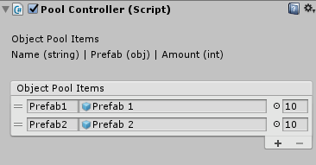

1. Spawn objects from the pool by using one line of code. Use the Name (string) of the required object, position to spawn and rotation:

using ObjectPooling;

PoolController.Instance.SpawnObject(“Prefab1”, Vector3.zero, Quaternion.identity);

IMPORTANT: Remember to include the using ObjectPooling namespace!

1. Pooled objects must contain a script which extends from **PoolObject**

Example:

using UnityEngine;

using ObjectPooling;

public class TestObject : PoolObject {

[SerializeField] private float moveSpeed;

[SerializeField] private float duration;

private float lifeTimer;

void Update ()

{

transform.Translate(Vector3.right * moveSpeed * Time.deltaTime);

lifeTimer += Time.deltaTime;

if(lifeTimer >= duration)

{

Destroy(); //Required

}

}

public override void OnObjectReuse() //Required

{

lifeTimer = 0;

}

}

Required: **Destroy()** method is called from the **PoolObject** base class.

Required: **OnObjectReuse()** method. Use this to reset any parameters when respawning.

Pooling example can be found in ObjectPooling/Example.

Contact me at [dave.flinders@hotmail.co.uk](mailto:dave.flinders@hotmail.co.uk), if you have any questions.

Cheers!